I ntroduction:
M odule 5 C AMS

A cam is a rotating machine element which gives reciprocating or oscillating motion to another element known as follower. The cam rotates usually at constant speed and drives the follower whose motion depends upon the shape of the cam. Almost always the cam is the driver and the follower is the driven. Cams come under higher pair mechanisms. As we already know that in higher pair the contact between the two elements is either point or line contact, instead of area in the case of lower pairs.
In a cam mechanism, the three essential members are:
  - The cam which has a curved surface or straight surface.
  - The follower and
  - The frame which supports and guides.

Cams are widely used in automatic machines, internal combustion engines, machine tools, printing control mechanisms and so on. Along with cam and follower one frame also will be there with will supports the cam and guides the follower.

C lassification of followers:
A follower can be classified in three ways:
- According to the motion of the follower
- According to the nature of contact
- According to the path of motion of the follower

. According to the motion of the follower

  - Reciprocating or Translating follower: When the follower reciprocates in guides as the can rotates uniformly, it is known as reciprocating or translating follower.
  - Oscillating or Rotating follower: When the uniform rotary motion of the cam is converted into predetermined oscillatory motion of the follower, it is called oscillating or rotating follower.
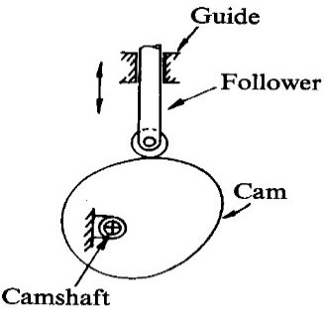
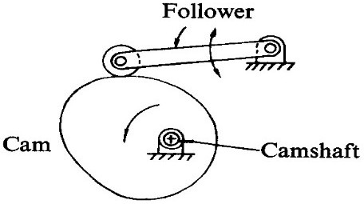

Reciprocating Follower Oscillating Follower

. According to the nature of contact:

  - The Knife-Edge follower: When contacting end of the follower has a sharp knife edge, it is called a knife edge follower. This cam follower mechanism is rarely used because of excessive wear due to small area of contact. In this follower, a considerable thrust exists between the follower and guide.
  - The Flat-Face follower: When contacting end of the follower is perfectly flat faced, it is called a flat faced follower. The thrust at the bearing exerted is less as compared to other followers. The only side thrust is due to friction between the contact surfaces of the follower and the cam. The thrust can be further reduced by properly offsetting the follower from the axis of rotation of cam so that when the cam rotates, the follower also rotates about its axis. These are commonly used in automobiles.
  - The Roller follower: When contacting end of the follower is a roller, it is called a roller follower. Wear rate is greatly reduced because of rolling motion between contacting surfaces. In roller followers, also there is side thrust present between follower and the guide. Roller followers are commonly used where more space is available such as large stationary gas or oil engines and aircraft engines.
  - The Spherical-Faced follower: When contacting end of the follower is of spherical shape, it is called a spherical faced follower. In flat faced follower’s high surface stress are produced. To minimize these stresses the follower is machined to spherical shape.
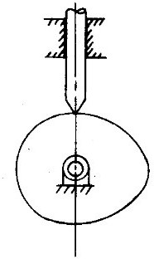
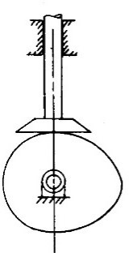
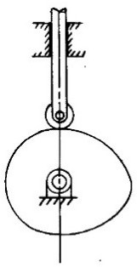
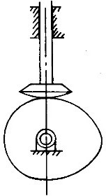
Knife-Edge follower Flat-Face follower Roller follower Spherical-Faced follower

. According to the path of motion of the follower:

  - Radial follower: When the motion of the follower is along an axis passing through the centre of the cam, it is known as radial follower.
  - Off-set follower: When the motion of the follower is along an axis away from the axis of the cam centre, it is called off-set follower.
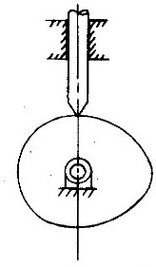
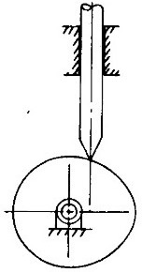
Radial follower Off-set follower

Classification of Cams:
Cams are classified according to their:
- Basic shapes
- Types of follower movement
- Manner of constraints of the follower

Classification according to basic shapes of the cams:
Plate or disk cams: Plate or disk cams are the simplest and most common type of cam. A plate cam is illustrated in figure below. This type of cam is formed on a disk or plate. The radial distance from the centre of the disk is varied throughout the circumference of the cam. Allowing a follower to ride on this outer edge gives the follower a radial motion.
Cylindrical or drum cam: A cylindrical or drum cam is illustrated in figure below. This type of cam is formed on a cylinder. A groove is cut into the cylinder, with a varying location along the axis of rotation. Attaching a follower that rides in the groove gives the follower motion along the axis of rotation.
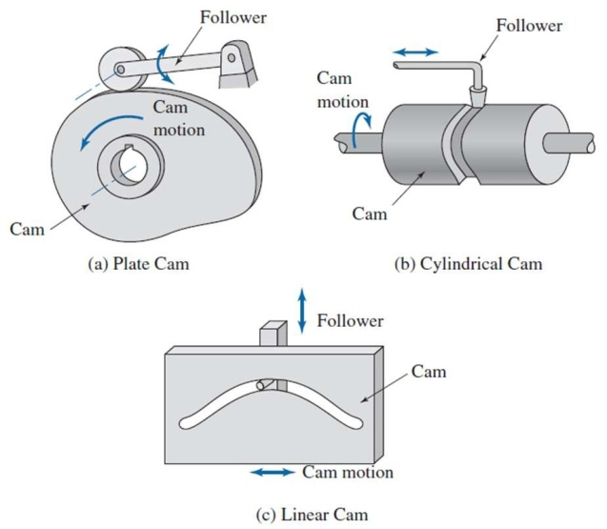
Linear cam: A linear cam is illustrated in figure below. This type of cam is formed on a translated block. A groove is cut into the block with a distance that varies from the plane of translation. Attaching a follower that rides in the groove gives the follower motion perpendicular to the plane of translation.

Classification according to movement of the follower:
The motions of the followers are distinguished from each other by the dwells, rises and returns they have.
Rise of a cam: The motion of the cam which tend to lift the follower is known as the rise motion.
Dwell of a cam: The rotation of the cam for which the follower is stationary at its position is known as dwell of the cam.
Return of a cam: The motion (rotation) of the cam for which the follower tends to move its original position is known as the return motion of the cam.

Cams are classified according to the motions of the followers in the following ways:
- Rise-Return-Rise (R-R-R): In this, there is alternate rise and return of the follower with no periods of dwells (as shown in figure). Its use is very limited in the industry. The follower has a linear or an angular displacement.
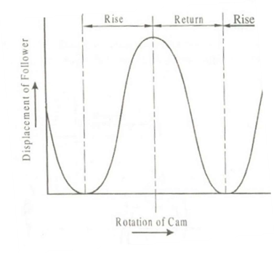
- Dwell-Rise-Return-Dwell (D-R-R-D): In such a type of cam, there is rise and return of the follower after a dwell (as shown in figure). This type is used more frequently than the R-R-R type of cam.
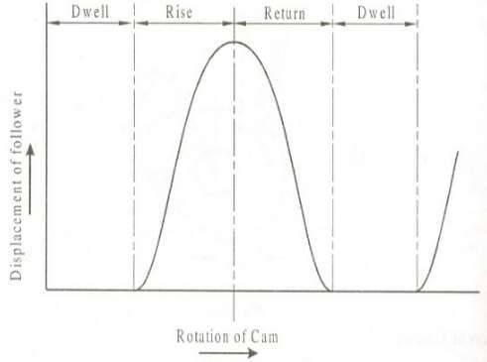
- Dwell-Rise-Dwell-Return-Dwell (D-R-D-R-D): It is the most widely used type of cam. The dwelling of the cam is followed by rise and dwell and subsequently by return and dwell as shown in Fig.
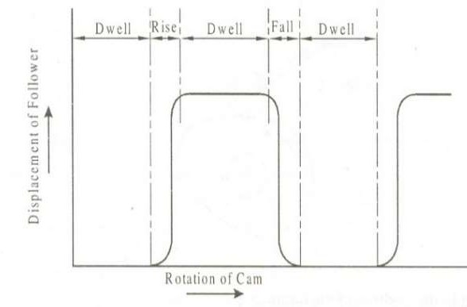

C lassification according to manner of constraint of the follower:
To reproduce exactly the motion transmitted by the cam to the follower, it is necessary that the cam and follower remains in touch at all speeds and at all times. The cams can be classified according to the manner in which this is achieved.
- Pre-loaded Spring Cam: A pre-loaded compression spring is used for the purpose of keeping the contact between the cam and the follower.

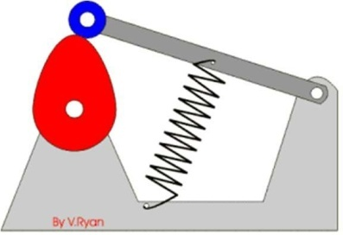
- Positive-drive Cam: In this type, constant touch between the cam and the follower is maintained by a roller follower operating in the groove of a cam. The follower cannot go out of this groove under the normal working operations. A constrained or positive drive is also obtained by the use of a conjugate cam.
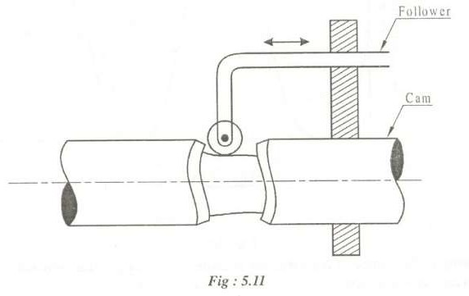
- Gravity Cam: If the rise of the cam is achieved by the rising surface of the cam and the return by the force of gravity or due to the weight of the cam, the cam is known as a gravity cam. However, these cams arc not preferred due to their uncertain behaviour.

Terminology in cams:
The various terms we will very frequently use to describe the geometry of a radial cam are defined as fallows.
- Base Circle: It is the smallest circle, keeping the centre at the cam centre, drawn tangential
to cam profile. The base circle decides the overall size of the cam and thus is fundamental feature.
- Trace Point: It is a point on the follower, and it is used to generate the pitch curve. Its motion describing the movement of the follower. For a knife-edge follower, the trace point is at knife-edge. For a roller follower, the trace point is at the roller centre, and for a flat- face follower, it is a t the point of contact between the follower and the cam surface when the contact is along the base circle of the cam. It should be note that the trace point is not necessarily the point of contact for all other positions of the cam.
- Pitch Curve: It is the curve drawn by the trace point assuming that the cam is fixed, and the trace point of the follower rotates around the cam, i.e. if we hold the cam fixed and rotate the follower in a direction opposite to that of the cam, then the curve generated by the locus of the trace point is called pitch curve. For a knife-edge follower, the pitch curve and the cam profile are same whereas for a roller follower they are separated by the radius of the roller.

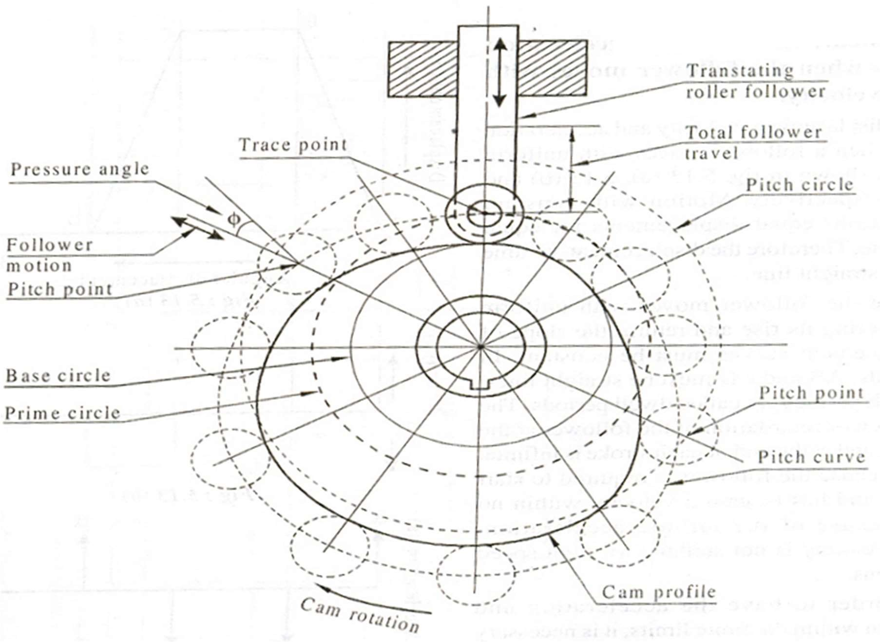
- Pressure Angle: It is the measure of steepness of the cam profile. The angle between the direction of the follower movement and the normal to the pitch curve at any point is called pressure angle. Pressure angle varies from maximum to minimum during complete rotation. Higher the pressure angle higher is side thrust and higher the chances of jamming the translating follower in its guide ways. The pressure angle should be as small as possible within the limits of design. The pressure angle should be less than 450 for low speed cam mechanisms with oscillating followers, whereas it should not exceed 300 in case of cams with translating followers. The pressure angle can be reduced by increasing the cam size or by adjusting the offset.
- Pitch Point: The point corresponds to the point of maximum pressure angle is called pitch point, and a circle drawn with its centre at the cam centre, to pass through the pitch point, is known as the pitch circle.
- Prime Circle: The prime circle is the smallest circle that can be drawn so as to be tangential to the pitch curve, with its centre at the cam centre. For a roller follower, the radius of the prime circle will be equal to the radius of the base circle plus that of the roller whereas for knife-edge follower the prime circle will coincides with the base circle.

Types of follower motion:
Cam follower systems are designed to achieve a desired oscillatory motion. Appropriate displacement patterns are to be selected for this purpose, before designing the cam surface. The cam is assumed to rotate at a constant speed and the follower raises, dwells, returns to its original position and dwells again through specified angles of rotation of the cam, during each

revolution of the cam. Some of the standard follower motions are as follows: They are, follower motion with,
- Uniform velocity
- Modified uniform velocity
- Uniform acceleration and deceleration
- Simple harmonic motion
- Cycloidal motion
Displacement diagrams: In a cam follower system, the motion of the follower is very important. Its displacement can be plotted against the angular displacement θ of the cam and it is called as the displacement diagram. The displacement of the follower is plotted along the y-axis and angular displacement θ of the cam is plotted along x-axis. From the displacement diagram, velocity and acceleration of the follower can also be plotted for different angular displacements θ of the cam. The displacement, velocity and acceleration diagrams are plotted for one cycle of operation i.e., one rotation of the cam. Displacement diagrams are basic requirements for the construction of cam profiles. Construction of displacement diagrams and calculation of velocities and accelerations of followers with different types of motions are discussed in the following sections.
- Follower motion with Uniform velocity:
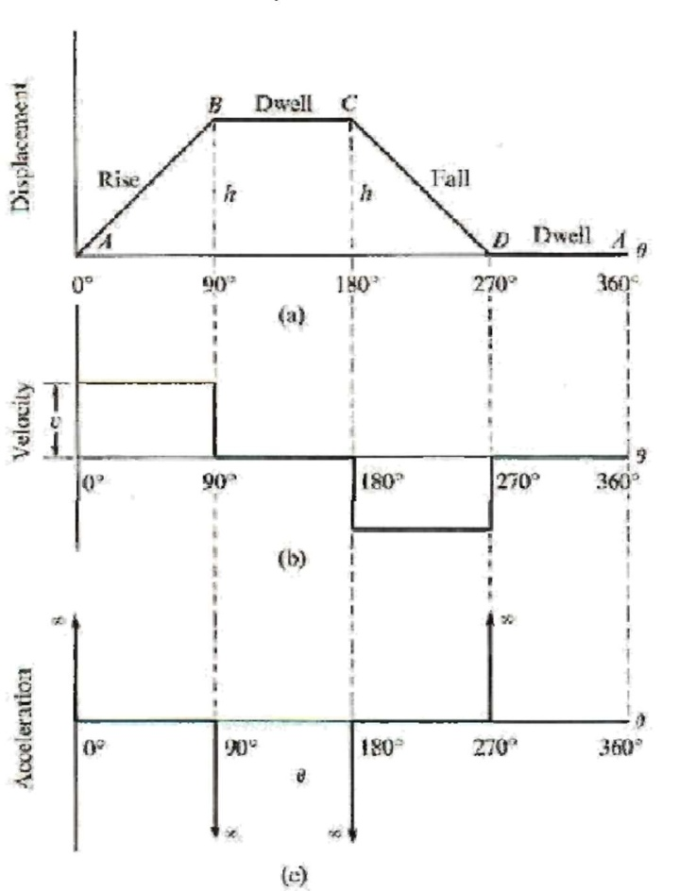
Fig. above shows the displacement, velocity and acceleration patterns of a follower having uniform velocity type of motion. Since the follower moves with constant velocity, during rise

and fall, the displacement varies linearly with θ. Also, since the velocity changes from zero to a finite value, within no time, theoretically, the acceleration becomes infinite at the beginning and end of rise and fall.

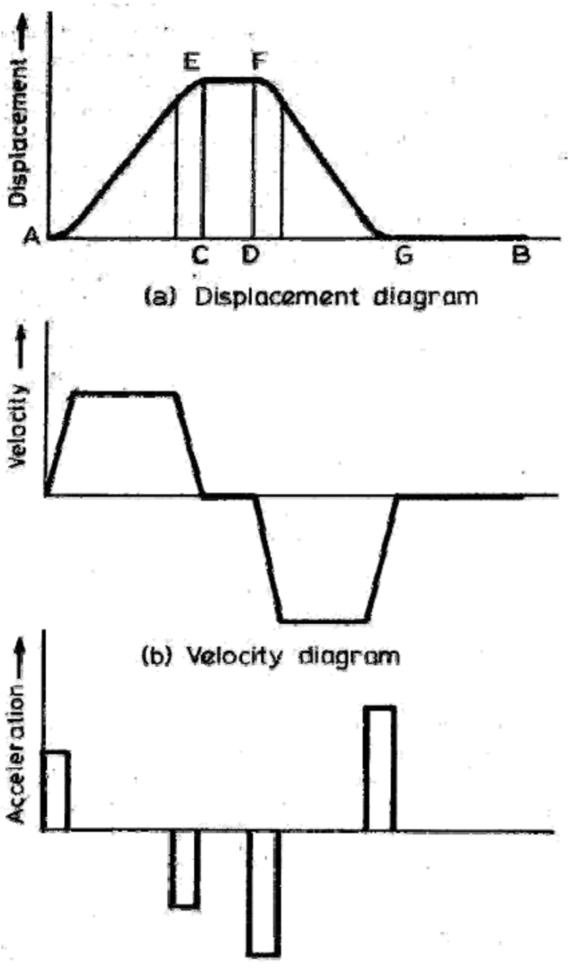
- Follower motion with modified uniform velocity: It is observed in the displacement diagrams of the follower with uniform velocity that the acceleration of the follower becomes infinite at the beginning and ending of rise and return strokes. In order to prevent this, the displacement diagrams are slightly modified. In the modified form, the velocity of the follower changes uniformly during the beginning and end of each stroke. Accordingly, the displacement of the follower varies parabolically during these periods. With this modification, the acceleration becomes constant during these periods, instead of being infinite as in the uniform velocity type of motion. The displacement, velocity and acceleration patterns are shown in fig. below.

- Uniform acceleration and deceleration: Noting that the velocity must be zero at the two ends, we can assume a constant acceleration for the first half and a constant deceleration in the second half of the cycle. The resulting motion curve will be two parabolas. This curve can be graphically drawn by dividing each half displacement into equal number of divisions

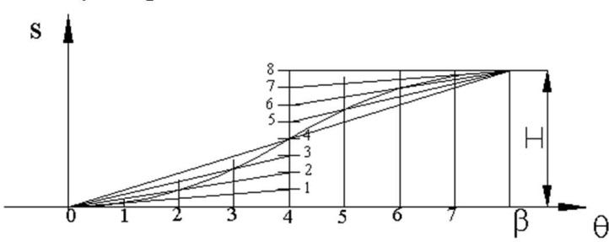
corresponding to the divisions on the horizontal axis and joining these points with O and O’ for the first and second halves respectively. Point of intersection of these lines with the corresponding vertical lines yield points on the desired curve as shown.

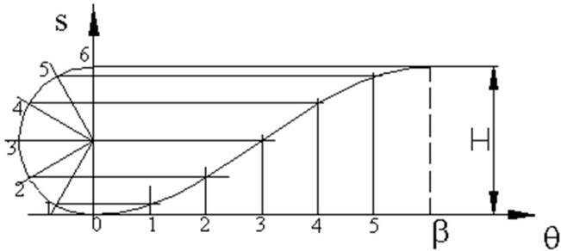
- Simple harmonic motion: Simple harmonic motion curve is widely used since it is simple to design. The curve is the projection of a circle about the cam rotation axis as shown in the figure. The equations relating the follower displacement velocity and acceleration to the cam rotation angle are:

Note that even though the velocity and acceleration is finite, the maximum acceleration is discontinuous at the start and end of the rise period. Hence the third derivative, jerk, will be infinite at the start and end of the rise portion. This curve will not be suitable for high or moderate speeds. In cases where the motion curve is composed of rise-return only, if the rise and return takes place for 1800 crank rotation each, simple harmonic motion curve results with a circular cam eccentrically pivoted (eccentricity = H/2, half the rise), as shown.

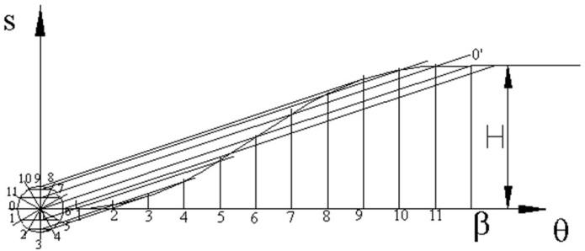
- Cycloidal motion: If a circle rolls along a straight without slipping, a point on the circumference traces a curve that is called a cycloid This curve can be drawn by drawing a circle with center C on the line OO’. The circumference of the circle is equal to the total rise; or the diameter is H/π. The circumference is divided into a number of equal parts corresponding to the divisions along the horizontal axis. The points around the circle are first projected to the vertical centreline of the circle and then parallel to OO’ to the corresponding vertical line on the diagram

Important Formulas:
Type of motion | Stroke | Maximum Velocity | Maximum  Acceleration
Simple Harmonic Motion | Out stroke | V = s  a 2  a | ❐ 2 2 s  aa = 2 2  a
 | In stroke | V = s  d 2  d | ❐ 2 2 s  ad = 2 2  d
Uniform acceleration and retardation | Out stroke | V = 2s  a   a | 4 2 s  aa =  2  a
 | In stroke | V = 2s  d   d | 4 2 s  ad =  2  d
Cycloidal motion | Out stroke | V = 2s  a   a | 2 2 s  aa =  2  a
 | In stroke | V = 2s  d   d | 2 2 s  ad =  2  d

Where sis Stroke in mm or m;
⬥ = 2N ;
60

❑ a is Angle of ascent in radians;  d is Angle of decent in radians.

A NALYSIS OF CIRCULAR CAM WITH FLAT FACED FOLLOWER
When the flanks of the cam connecting the base circle and nose are of convex circular arcs, then the cam is known as circular arc cam. A circular arc cam is made up of 3 arcs of different radii. In such cam, the acceleration may change abruptly at the bending points due to instantaneous change in radius of curvature. A symmetrical circular arc cam operating a flat faced follower is shown in figure below in which O and Q are the centres of the cam and nose respectively.
Let, rb= Minimum radius of cam or the base circle radius = OB rn= Radius of nose
rf = Radius of circular arc flank
l = distance between cam and the nose centre
α= semi-angle of action
θ= angle turned by the cam from the beginning of the follower motion
We shall consider the following two cases:
  - When the flat face of the follower has contact on the circular flank, and
  - When the flat face of the follower has contact on the nose.

In deriving the expressions for displacement, velocity and acceleration of the follower for the above two cases, it is assumed that the cam is fixed and the follower rotates in the opposite sense of the cam. In the figure below the cam is rotating in the counter-clockwise direction and the follower rotates in clockwise direction.

Case 1: When the flat face of the follower has contact on the circular flank:
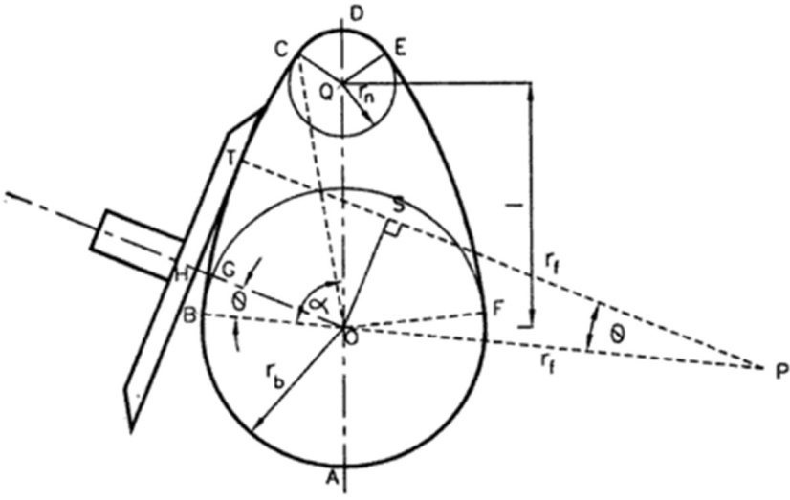
Let us consider that the flat face of the follower has contact at point T on the circular flank. It is lifted to a distance GH. Let P be the centre of the circular arc of the flank and rf = PB=PT. Lift of the follower, when the cam has rotated through an angle θ is given by,
x = OH – OG
= TS - OG
= (PT - PS) – OG
= PT – OPcosθ – OG
= PT – (PB – OB) cosθ – OG
= rf – (rf – rb) cosθ – rb
= rf – rfcosθ – rbcosθ – rb
= rf (1– cosθ) – rb (1- cosθ)
x = (rf – rb) (1- cosθ)
Differentiating with respect to t we get,
v = dx = dx d dt d dt
v = (rf – rb) sinθ . ω
⸫ v = ω (rf – rb) sinθ
Velocity of the follower, i.e. v is zero when θ = 0 i.e. when the follower starts ascending. It increases with θ and is maximum or when the follower moves the flank and θmax = β.
⸫ Vmax = ω (rf – rb) sinβ
Differentiating v with respect to t, we get,
a = dv = dv d dt d dt
a = ω [(rf – rb) cosθ] ω
⸫ a = ω² (rf – rb) cosθ
Acceleration of the follower i.e. a is maximum when θ = 0 i.e. when the rise commences
Amax = ω² (rf – rb)
and Amin = ω² (rf – rb) cosβ where θmax = β.

Case 2: When the flat face of the follower has contact on the nose
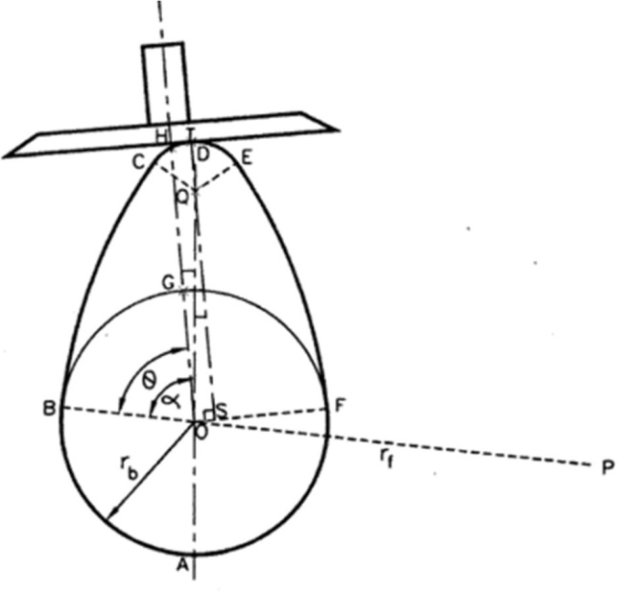
As the figure shows, when flat-faced follower touches point T on the nose, it is lifted through a distance GH. Then lift of follower, when cam has rotated through angle θ is given by:
x = OH – OG
= QT + QS – OG
= QT + OQ cos (α - θ) – OG
= rn + l cos (α - θ) – rb
Differentiating x with respect to t, we get:
v = dx = dx d dt d dt
= - [l sin (α - θ)]. [- ω]
v = lω sin (α - θ)]
Velocity of the follower is minimum i.e. v = 0 when α = 0 i.e. when the follower is at the apex of the circular nose and it starts descending. And the velocity of follower is maximum when (α - θ) is maximum i.e. when θ is minimum i.e. when the follower just touches the nose of the cam. i.e. at the θmax = β as discussed earlier.
Differentiating with respect to t we get,
a = dv = dv d dt d dt
= lω [cos (α - θ)] (-ω) where ω is uniform
⸫ a = -lω2 cos (α - θ)
i.e. it is a retardation.
Retardation is maximum when (α - θ) is minimum when α - θ = 0 i.e. when α = θ i.e. follower is at the apex of the nose.
& Amax = -lω²
Also, the retardation is minimum when (α - θ) is maximum i.e. when θ is minimum i.e. when the follower just touches the nose of the cam.

